User guide for the pendulum program:

1. Extract the files from the zipped file

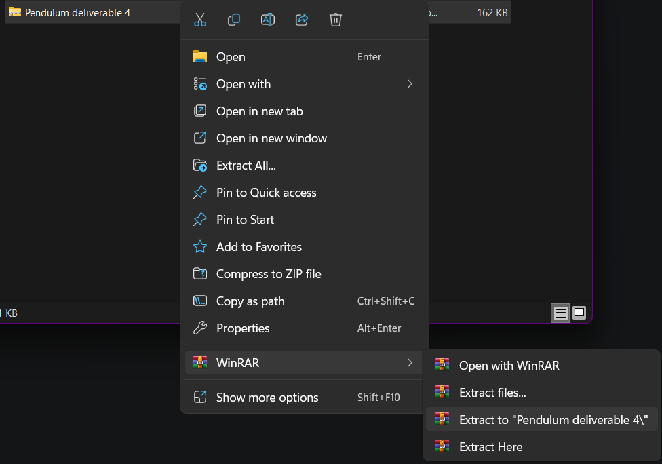

1. Open main_window.py

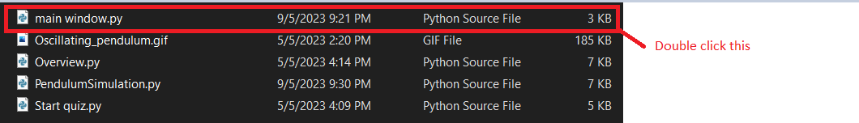

Steps to use Pendulum Simulator:

1. The main window consists of 4 buttons with self-named functions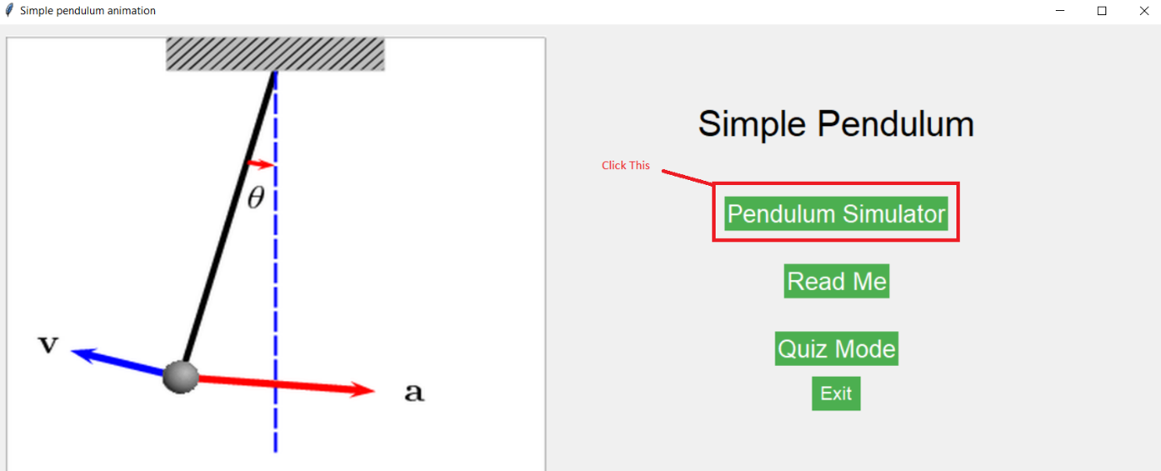
2. The first button opens the simulation window, the second opens instructions and important information regarding the simulation, the third button opens a quiz window for the simulation and the fourth button closes the program.
3. Click Pendulum Simulator Button to open the simulation window as shown below

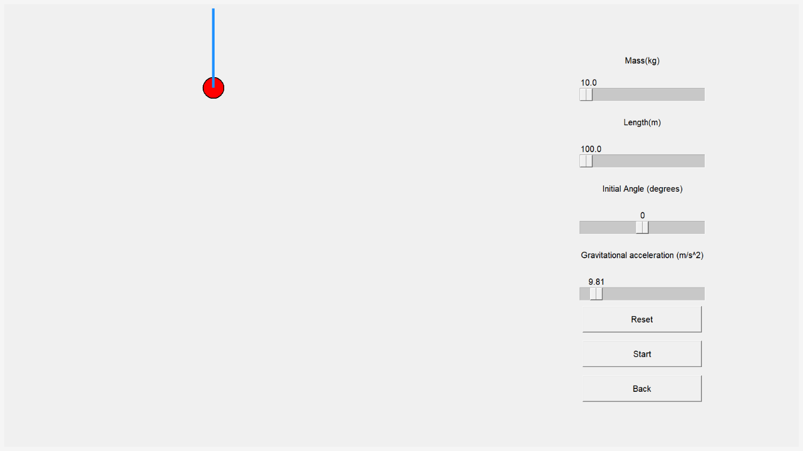

1. Adjust sliders to change the variables of the pendulum
2. Click Start button to begin, a new window will pop up which displays the energy values of the pendulum’s period
3. Do not close this window and instead leave it open until you want to go back. Use alt+tab to bring it back into view if it disappears
4. Press the reset button to reset the pendulum’s position and default the sliders
5. To go back to the main menu, click back and you will be taken back

That concludes a brief explanation of the setup for our program, more information can be found in the readme window in the program itself. Thank you for using our program and we hope you enjoyed it.